Dear friends,
4 member delegation from JNV EAST GODAVARI DIST. A.P. met Honorable Minister For Human Resource Development, at his residence, Kakinada on 20/04/2013 to request about the pension issue.
He spent 25 minutes of time with our delegation. He was very sympathetic, positive towards pension. He revealed us that he had discussed with Finance minister and it seems convinced him on the very just demand of us.
“I am on that work. Somehow it was ignored. I explained your extra work when compared with K.Vs to Finance Minister and Soniaji. In principle they accepted. Accordingly the Cabinet Note is prepared. It is in the process. Don’t worry. I am working on it."----MHRD Mr. Pallam Raju.
Honourable Minister is well aware of the issue and gave a hope of getting it soon.
Yours
K matta reddy
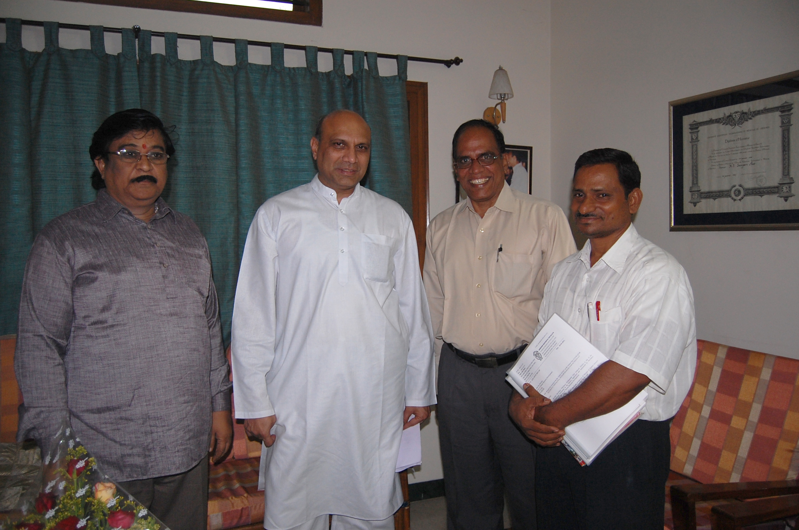
JNV, East Godavari (A.P) Principal & other staff

